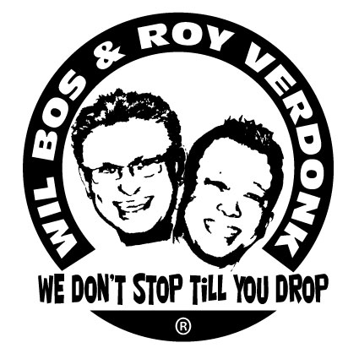
Show Me Your Teeth

Choreographed by : Roy Verdonk & Wil Bos
Level : Intermadiate
Counts : 64 counts
Walls : 2 wall Linedance
Music : Lady Ga Ga - Show Me Your Teeth
Start : 32 counts on heavy beat

STOMP SWIVEL R&L, SYNCOPATED ROCK STEPS, R SAILOR STEP
1&2 stomp R forward, Turn R heel out, turn heel back
3&4 stomp L forward, Turn L heel out, turn heel back
5&6& Rock R forward, Recover on L, Rock R to R side, Recover on L
7&8 Cross R behind L, Step L to L side, Step R to R side

L SAILOR ½ TURN L, R SHUFFLE FWD, STEP TOUCH, STEP HOOK, L SHUFFLE FWD
1&2 Sailor ½ turn L, L, R, L
3&4 Step R forward, Step L next to R, Step R forward
5&6& Step L forward, Touch R toe behind L heel, Step R back, Hook L across R Knee
7&8 Step L forward, Step R next to L, Step L forwardStap LV voor, sluit RV naast, Stap LV voor

PADDLE ½ TURN R, CROSS & HEEL, & CROSS, & BEHIND, & CROSS SHUFFLE
1&2 ¼ Turn L-touch R to R side, hitch R knee, ¼ turn L- touch R to R side
3&4 Cross R over L, Step L to L side, Touch R heel fwd
&5&6 Step R next to L, Cross L over R, Step R to R side, Cross L behind R
&7&8 Step R to R side, Cross L over R, Step R to R side, Cross L over R
SIDE TOGETHER, ¼ TURN L, FULL TURN R, SYNCOPATED JAZZ BOX WITH ¼ L, TOUCH-HITCH-TOUCH, STEP TOGHETER
1&2 Step R to R side, Step L next to R, ¼ turn L step R fwd
3-4 ½ turn R-Step L back, ½ turn R-step R fwd
5&6& Cross L over R, ¼ turn L-step R back, Step L to L side, Cross R over L
7&8& Touch L to L side, Hitch L across R, Touch L to L side, Step L next to R

PIVOT ½ TURN L, PIVOT ¼ TURN L, DIAGONAL STEPS BACK WITH TOUCHES X4
1-2 Step R fwd, ½ Turn L-weight on L
3-4 Step R fwd, ¼ Turn L-weight on L
5&6& Step R diagonal back, Touch L next to R, Step L diagonal back, Touch R next to L
7&8& Step R diagonal back, Touch L next to R, Step L diagonal back, Touch R next to L

SIDE TOGETHER, SIDE TOUCH, HEEL-HOOK, HEEL-TOUCH, VINE ¼ TURN L, HEEL-HOOK,HEEL-TOUCH
1&2& Step R to R side, Step L next to R, Step R to R side, Touch L next to R
3&4& Touch L heel fwd, Hook L across R knee, Touch L heel fwd, Touch L next to R
5&6& Step L to L side, Cross R behind L, ¼ turn L-step L fwd, Touch R next to L
7&8& Touch R heel fwd, Hook R across L knee, Touch R heel fwd, Touch R next to L

SIDE TOGETHER, SIDE TOUCH, HEEL-HOOK, HEEL-TOUCH, VINE ¼ TURN L, HEEL-HOOK, HEEL-STEP TOGETHER
1&2& Step R to R side, Step L next to R, Step R to R side, Touch L next to R
3&4& Touch L heel fwd, Hook L across R knee, Touch L heel fwd, Touch L next to R
5&6& Step L to L side, Cross R behind L, ¼ turn L-step L fwd, Touch R next to L
7&8& Touch R heel fwd, Hook R across L, Touch R heel fwd, Step R next to L

PIVOT ¼ TURN R, CROSS SHUFFLE, SIDE ROCK & L SHUFFLE FWD
1-2 Step L fwd, ½ turn R-weight on R
3&4 Cross L over R, Step R to R side, Cross L over R
5-6& Rock R to R side, Recover on L, step R next to L
7&8 Step L fwd, Step R next to L, Step L fwd

